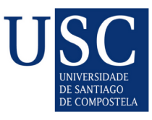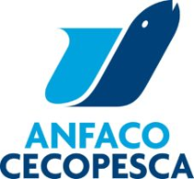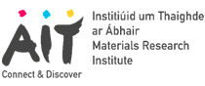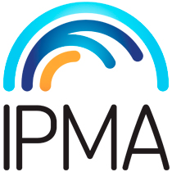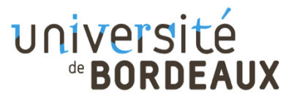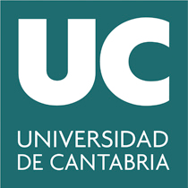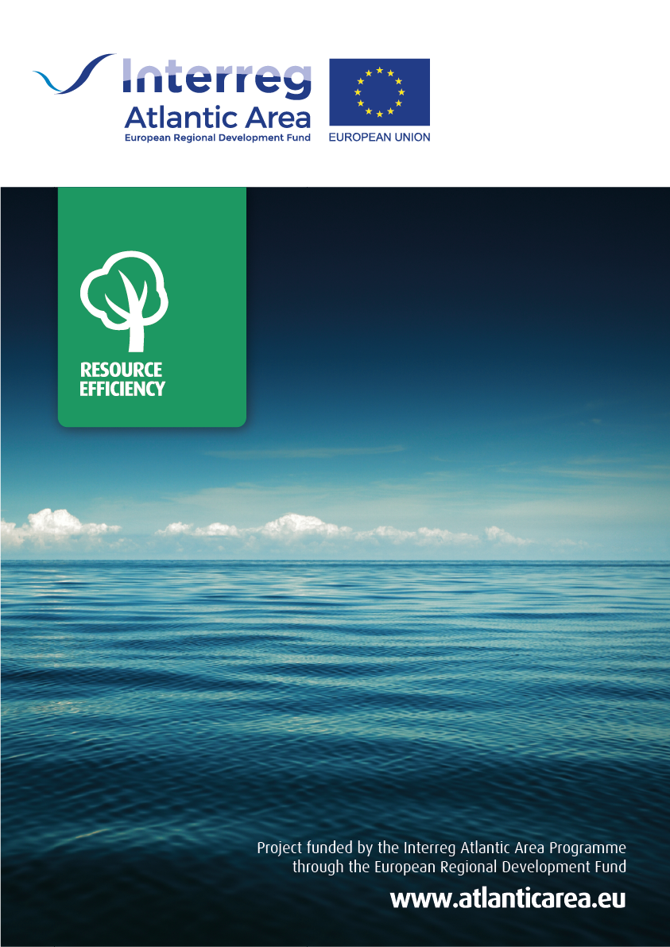

**www.neptunus-project.eu**

The NEPTUNUS project aims to promote the sustainable development of the seafood sector in the Atlantic Area by supplying a consistent methodology for products eco-labelling and defining eco-innovation strategies for production and consumption under a circular economy approach. This project will provide key actions for resource efficiency based on life cycle thinking, incorporating producers, policy makers and consumers in the decision making process.

June 2019 | June 2022

ERDF funding 1,734 M€

Total budget 2,312M€

**NEPTUNUS**

Water-energy-seafood nexus: eco-innovation and circular economy strategies in the Atlantic Area